1. Install VS 2015 and the Secondary Installer.
2. Make sure the Secondary Installer is installs, if not you can install it manually

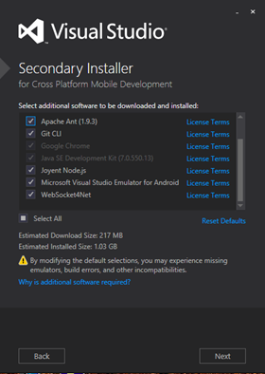

C:\Program Files (x86)\Microsoft Visual Studio 14.0\SecondaryInstaller

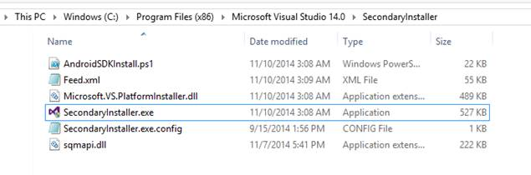

On successful installation you should see the folder

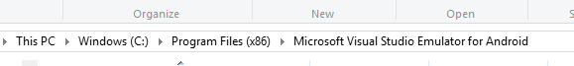

You should see XDE.exe, double clicking on the XDE.exe does not work.

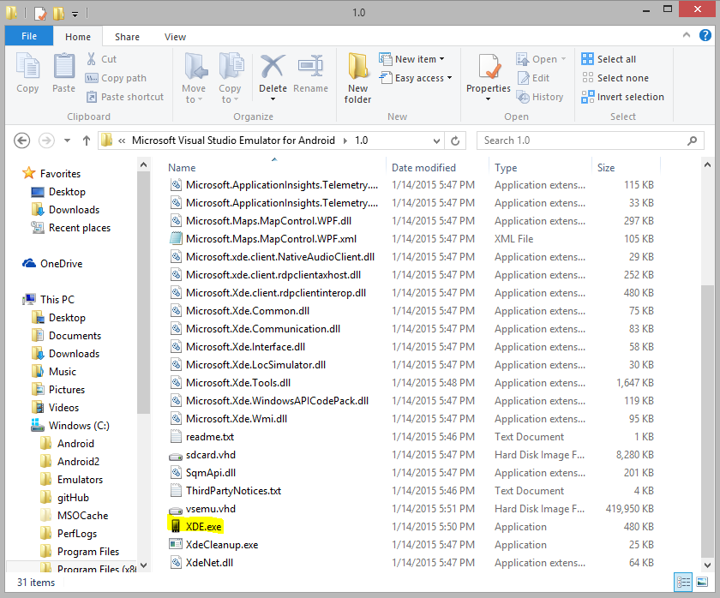

You need the following steps

1. Create a shortcut for XDE.exe on the desktop

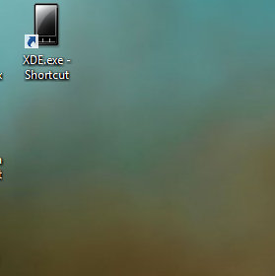

1. Next copy the vsemu.vhd to a different folder

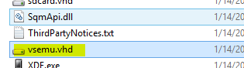

I have put it under C:/Emulators

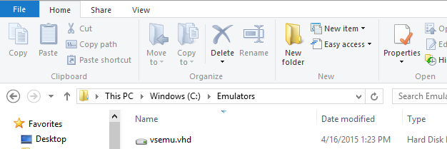

1. Changing the launch target. Right click the shortcut -> Properties

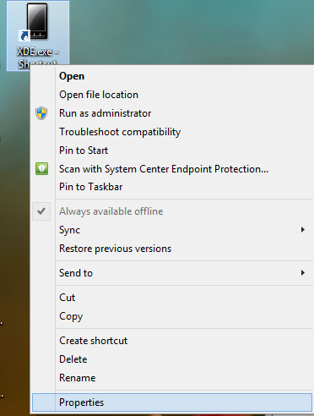

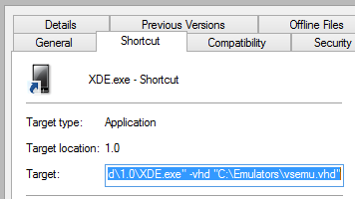

And under target write the following

"C:\Program Files (x86)\Microsoft Visual Studio Emulator for Android\1.0\XDE.exe" -vhd "C:\Emulators\vsemu.vhd"

Apply -> Ok

Now double click the emulator. (It takes 5 – minutes to start).

Also requires admin rights to run!!!

It may give the error “Could not locate ADB.exe”. If it does then follow the steps below.

“Could not locate ADB.exe”

In this case the emulator starts but is not connected to the ADB server and hence not detected by Xamarin Studio or any other IDE.

In such a case we need the ADB to connect to the Emulator.

1. On the VS emulator click on the arrow to open up additional tools, click on the Network tab

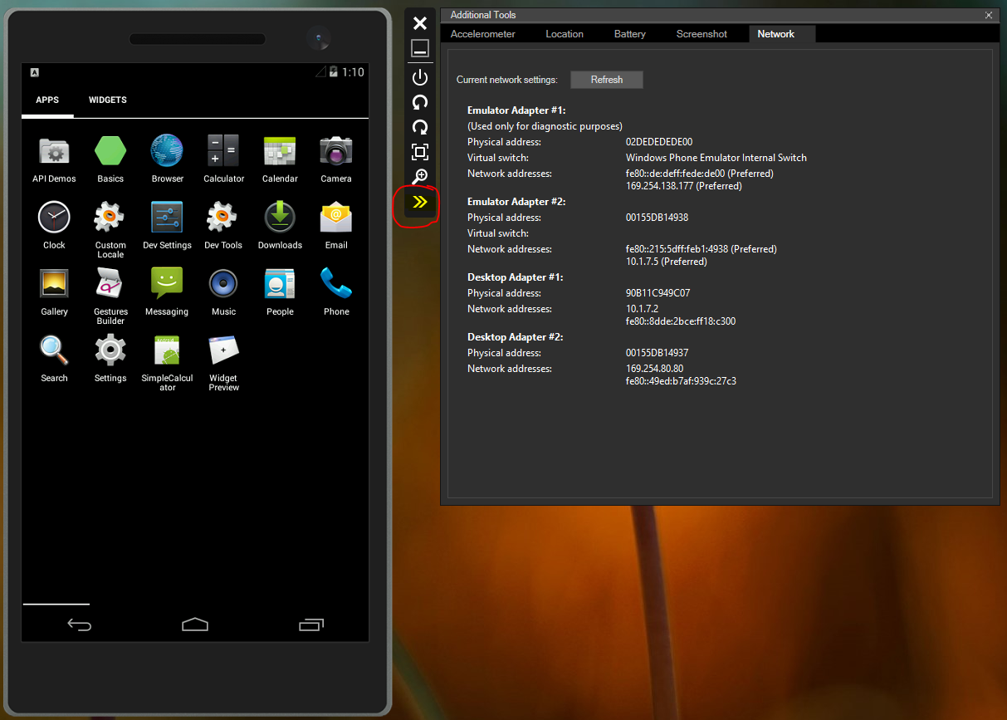

1. Make a note of the IP address

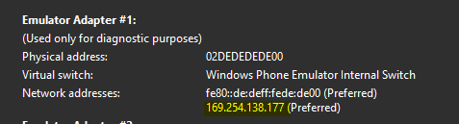

1. Go to your android- sdk/ platform tools folder, copy it and paste it in your command prompt



And type the command adb connect <ip_address>:5555

You should get a message



Now when you go adb devices



You should see your device connected.

Now Xamarin should recognize your device.

Deploying an App on the Visual Studio emulator

When you run and deploy the app from Xamarin Studio, you need to set the following options for the app to run on the VS emulator.

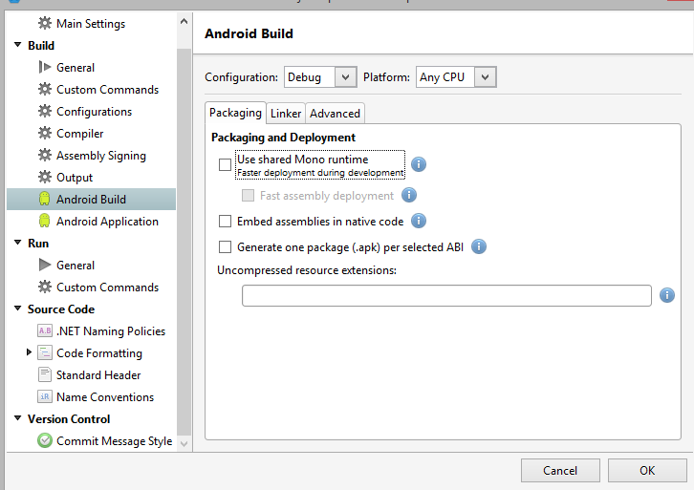

Uncheck the Fast Assembly deployment and using shared Mono runtime

And check the x86 option

